# Paybox mission – Full stack (NodeJS)

Build a Web Application with the following requirements:

1. Create express server: “Auth service”

* Typescript
* Add a connection to mongoDB.
* Create Users schema (username: paybox, password: paybox).
* Add Authentication via JWT / (any package you want to use – passport).
* Send data & requests to “Missions service” with AES encryption.
* Receive the data from “Missions service”, decrypt it and send to the client.
* Add audit log schema for create, update, and delete operations.
* Unit tests
* README file

1. Create express “Missions service”

* Typescript
* Use the same mongoDB connection from “Auth service”.
* Create Missions schema: {key: String, value: JSON}.
* JSON: {“a”: {“b”: {“c”:”d”}}} – nested json.
* Get the data from “Auth service” – decrypt it and save to MongoDB.
* Unit tests
* README file
* Typescript

1. Handle 4 routes:

* Get
* Create
* Edit
* Delete

1. Create React/Angular client application

* View
* Typescript
* Buttons for: create, update and delete.

Additional information:

* ES6+
* MVC Architecture.
* Data encryption transport.
* Audit log.
* Clean code.

Extra (not mandatory):

* Create a cron job to remove logs older than 5 hours (every 30 minutes).

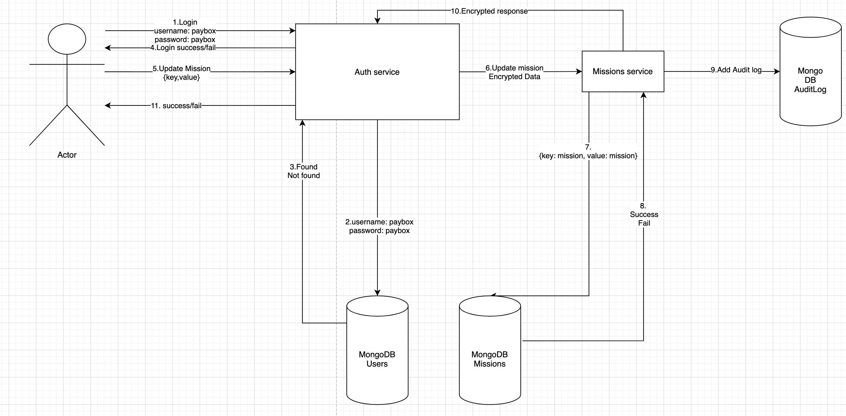

Good luck ☺